MGMS – Apply to proposal

Functional Specification Document

Ver. 1.4

Version History
Date | Description
11-Dec-2010 | First Draft

Table of Contents

Version History 2
1 Introduction 4
1.1 Purpose 4
1.2 Scope 4
1.3 Assumptions 4
1.4 Constraints 4
2 Apply to proposal 4
3 Business Rules 5
4 Status Messages 5

Introduction

Purpose

This document provides the requirements and functional specifications for the Proposal application related features of the Multisite Grant Management System application.
This is not a project plan or a design document. It is a guide for system architecture and development, not for phasing, timelines or deliverables.
Finally, this is a ‘living document’ and the specification will change, continuously, as the project proceeds. More details will be added and the existing information edited as the requirements, scenarios and use cases evolve in the course of the project.

Scope

It is required that every organization which is part of the MGMS be enabled to upload own application form which will be displayed to the corresponding users by default. Currently application form can be uploaded as part of the notification creation for each request for proposal. The interested parties can download and edit these forms. Institution specific form will be included when the requirement is confirmed.
The above is in conjunction with the need for accommodating unsolicited proposals i.e. facility for any one to create and submit a proposal independent of a notification (request for proposal). This will be taken up in a future build.

Assumptions

Constraints

Apply to proposal

Screen & Control Description

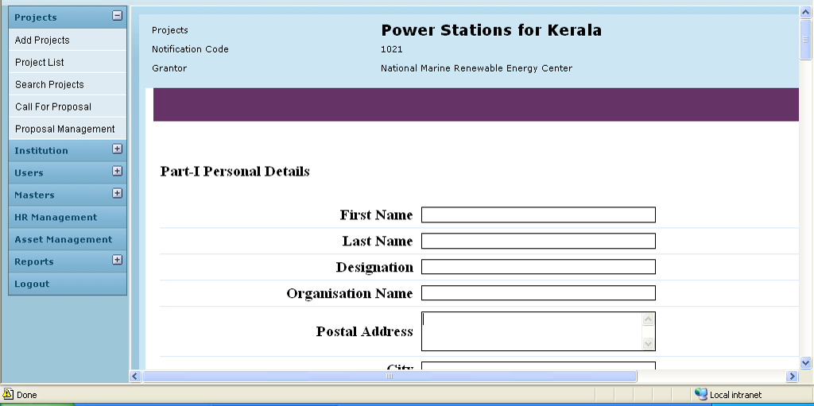

Field /Label | Input-Control | Data Type
Projects | Auto populated | projects>name
Notification Code | Auto populated | notification>notification_code
Grantor | Auto populated | party>name_of_the_institution
The relevant application form is expanded in editable format.
Save | Button

Business Rules

Status Messages

Sl No | Status Message
1 | Created Successfully
2 | Updated Successfully
3 | Deleted Successfully
4 | The Requested Record Not Found
5 | The Record can't be deleted, Already in use
6 | The Record Already Exists
7
8

